FAQs on EXIT

Clearance 2

Allsec Exit Forms 2

Investments proof submission 3

Allsec Alumni Portal 3

Form 16 3

Leave encashment 3

Notice period Recovery 4

Provident Fund – PF 5

Gratuity 8

Corporate card 8

Medical Insurance 8

Car lease and other benefits 9

Full and Final payment 4

Personal belongings at office 9

Back Ground Verification 10

Contact Email 10

# Clearance

1. **Who will handle my exit clearances and what are the formalities required?**

The Offboarding Team will centrally manage your exit-related clearances. In case of any queries, you may reach out to the team at <Exitindia@publicissapient.com>. For the offboarding formalities, please refer to the Next Steps email.

1. **When will I get the payroll clearance?**

Payroll clearance will be granted on the last working day, after clearances provided by Benefits, Expense, Global Mobility and Procurement teams.

1. **Will I receive any email for payroll clearance?**

Clearance to a person is provided by all stakeholders on Exit tool.

1. **When will I get the IT clearance?**

IT clearance will be granted once you submit all your IT assets and accessories. Asset pickup facility is not available for people in any ofﬁce location (Delhi/NCR, Mumbai, Hyderabad, Pune or Bengaluru). Visit ofﬁce in person on your last working day or before for assets submission.

If you are outside Delhi/NCR, Mumbai, Hyderabad, Pune or Bengaluru ** – Please ﬁll in the mandatory [Personal Information form](https://forms.office.com/r/c0iNbbwpW4)

Please note, in case of non-submission of assets, on or before the last working date, or within 5 working days of the last working day (for people outside ofﬁce locations / remote workers), the company holds the right to initiate a legal action for recovery.

1. **Where can I submit my IT assets?**

Please note IT assets tagged to:

* + **Gurgaon SEZ** – Can be submitted at all office location except NOIDA SEZ
  + **NOIDA SEZ** - Can be submitted at all office location except Gurgaon SEZ office
  + **Any other location apart from NOIDA & Gurgaon SEZ** - Can be submitted at all office location except Gurgaon & NOIDA SEZ office

1. **When can I visit office for submitting the IT assets?**

You can return the asset in ofﬁce from Mon to Friday only between 9:00 AM to 5:00 PM. While you are submitting your assets in ofﬁce or to the vendor, take photos of your assets. Share the photos to EXIT_FSIT_PUB_TEAM_IND [FSIT.exitIndia@publicis-resources.com](mailto:FSIT.exitIndia@publicis-resources.com).

# Allsec Exit Forms

1. **What will be the next steps on Allsec for exit formalities?**

You need to fill the leavers form at [Allsec](https://www.allsechro.com/Publicisgroupe) portal under ‘Utilities’. Once you fill and submit the form, you’ll get the prepopulated form, i.e., Leave Encashment and Gratuity Declaration form. This will be applicable if you been in the organization for 4 years and 190 days, or more.

You do not need to submit any hard copy. Please complete the formalities 7-10 days prior to your exit date.

1. **What needs to be filled in place of c/o, or what does this mean under leavers form tab?**

“Care of” alias C/o will be used in address to fill in the name of the person who will represent you in receiving any communication from us.

1. **Allsec system is not taking ‘space’ (I am unable to use ‘space’) while entering address details in C/o column?**

It is fine, please enter your address without giving space.

1. **What needs to be filled in place of details required for Gratuity exemption claimed u/s 10 (10) ii of the act?**

If you have claimed exemption for Gratuity in your previous company, then fill the name of the employer, Financial Year (FY) it belongs to and the exemption amount. You can get these details from the previous company’s Full & Final (F&F) settlement tax sheet.

If you do not have any exemption, please keep it blank and proceed to submit the page. If you are unsure and do not want to put details, you can leave it blank and submit.

However, if the Income Tax department issues any demand notices, you need to be ready with an answer. As per the Income Tax Act, an individual can get maximum tax benefit of INR 20,00,000/- in their entire service.

1. **What needs to be filled in the section about details required for Leave exemption claimed u/s 10 (10) ii of the act?**

If you have claimed Exemption for Leave in your previous company, then fill the name of the employer, Financial Year (FY) it belongs to and the exemption amount. You can get these from your previous company’s Full & Final settlement tax sheet.

If you do not have any exemption, please keep this space blank and proceed to submit the page. If you are unsure and do not want to put details, you can leave it blank and proceed to submit the page.

However, if the Income Tax department issues any demand notices, you need to be ready with an answer.

As per Income Tax Act, an individual can get maximum tax benefit of INR 3,00,000/- till FY 2022-23 and INR 25,00,000/- effective FY 2023 -24. The mentioned limit includes all previous employment leave encashment amounts.

1. **Date of Leaving is not showing in the leavers form. Will this impact anywhere?**

No, this will not impact anywhere. You can proceed to submit the leavers form page.

# Investment proofs submission

1. **When and where do I need to submit my investment proofs?**

All investment proofs need to be submitted at the [Allsec](https://www.allsechro.com/Publicisgroupe) portal. You’ll find the ‘Investment proof submission’ page under the ‘Tax’ tab on the top navigation bar. Please submit the same **7**-**10 days prior to your exit date.** If you had already submitted investment proofs during the current Financial Year (FY), then you don’t need to submit again.

1. **What will happen if I cannot/do not submit my Investment proofs on time?**

If we do not receive any investment proofs, we will be unable to provide your income tax benefits, and your tax deductions will happen accordingly. You can, however, claim the tax benefits in your next organization except HRA.

# Allsec Alumni Portal

1. **How will I get Alumni portal access after my exit date?**

You will get further communication from Allsec within 48-72 hrs from your exit date. You will be provided a new User ID and password to access the portal. If you face any issue in getting access, you may reach out to the team at <Exitindia@sapient.com>.

Please update your personal email Id in Career Settings (CS) to get the email from Allsec with Alumni portal access details. Check your junk folder also for the email from Allsec.

# Form 16

1. **How will I get my Form 16 for FY 22-23 after my exit?**

Your Form 16 for the current financial year will be available by next financial year, after July in the Alumni portal.

# Leave encashment

1. **What will happen to my remaining Paid Leave (PL) balance?**

Your vacation days balance will be paid along with your Full & Final(F&F) settlement.

**Calculation:** Last drawn Annual Base salary / 312 x No. of vacation balances

*Please refer to your compensation/last salary increment letter to know your Base salary*

As per New [**India Vacation Policy**](https://vox.publicissapient.com/home/ls/content/4518857729376256/INDIA-vacation-policy-effective); Any PL over and above 45 days will neither be carried forward nor encashed.

1. **Will leave encashment be paid as a taxable or non-taxable component?**

Leave encashment will be paid as a non-taxable component for up to INR 3,00,000/- till FY 2022-23 and INR 25,00,000/- effective Financial Year (FY) 2023 -24. The mentioned limit includes all previous employment leave encashment amounts.

Please make sure you submit the leavers declaration form at Allsec portal to get exemption.

# Notice period Recovery

1. **Will I get any letter from Publicis Sapient for notice period buyout?**

The ‘shortfall in notice period’ amount will reflect in your Full & Final (F&F) settlement sheet under the head of “**Notice period recovery**”. Any separate letter will not be issued for the same. If you need a separate letter, please write with this requirement to [exitindia@publicissapient.com](mailto:exitindia@publicissapient.com%20) or reach out to your exit POC , prior to your exit date.

1. **If I do not want to adjust the shortfall in notice period with the accrued vacations, so that I can get reimbursement/buyout from next company, What will be the next steps for this?**

Once your exit is initiated, you need to inform [exitindia@publicisssapient.com /](mailto:exitindia@publicisssapient.com%20/%20) Exit GPC POC. Your payroll POC will let you know the amount, along with the bank details towards which you need to pay the amount of ‘shortfall in notice period’.

1. **If I have any shortfall in notice period, how is it calculated at the time of Full & Final settlement?**

The ‘shortfall in notice period’ amount will be adjusted with your accrued vacation days balance (only positive) and the remaining balance of ‘shortfall in notice period’ will be recovered through your Full & Final settlement, or you’ll be asked to make an online fund transfer to Publicis Sapient’ s account.

To give an example of calculating your ‘shortfall in notice period’, say you have 10 days’ shortfall in notice period and 6 days’ vacation balance. In this case, your

6 days of vacation will be adjusted with the ‘shortfall in notice period’ amount and the remaining ‘shortfall in notice period’ amount of 4 days (10 - 6 days) will be recovered from you. Vacation balance will be shown as zero.

1. **Calculation of shortfall in notice period:** (Annual Base Salary / 12 x no. of notice shortfall days)/ 30
2. **What happens if my vacation balance is positive even after adjusting my ‘shortfall in notice period’?**

If your vacation balance is positive, after adjusting your shortfall in notice period (if any), then you will receive leave encashment “for remaining days of vacation” along with your F&F amount.

1. **Can I get draft F&F calculation prior to my exit?**

No, there is no draft calculation from Allsec.

# 

# Full and Final (F&F) payment

1. **When will I receive my full and final settlement?**

Our endeavor is to make your Full & Final (F&F)settlement within 15-30 days from your exit date. This is subject to receiving all your clearances till your exit date.

1. **What is the mode of payment for Full & Final settlement?**

The F&F settlement amount will be directly credited to your salary account of Publicis Sapient. Please keep your salary account active till you receive your F&F settlement.

1. **What if I wish to change the bank account for Full & Final (F&F) settlement credit?**

Update the account number in your Career Settings (CS) prior to your exit, so that you can get the F&F credit in the same account.

1. **Will I get the break-up of the F&F settlement amount?**

After you receive the F&F amount, you will need to login to Alumni portal to view the Full & Final (F&F) settlement statement (break-up).

1. **Whom should I contact if I do not receive my Full & Final settlement as per the specified timeline, or if I have any other query?**

If you have any query with respect to Form 16 or Full & Final settlement sheet, after receiving the amount, please raise a ticket at the [Allsec](mailto:IndiaPayrollExit@publicissapient.com) Alumni Portal.

For any other query, related to relieving letter, experience letter, OS, benefits, Amex, and IT assets, after your exit, please write to [Exitindia@publicissapient.com](mailto:Exitindia@publicissapient.com)

1. **What will be included in my Full &Final settlement?**

Your Full & Final settlement will include your salary till your last day, your vacation days balance, and any other payout as a part of your exit package. The settlement will also factor in any deductions in lieu of taxes, damages to asset, outstanding expenses, benefits enrollment, etc., depending on the clearances received from stakeholders.

1. **If I have resigned, will I get salary for the current month?**

If your exit date is on or prior 15th of a month, then current month’s salary will not be processed. You'll get the same while processing full & final settlement.

For any other query, please write to [Exitindia@publicissapient.com](mailto:Exitindia@publicissapient.com)

1. **When will I receive my Relieving and Experience letter?**

Relieving and Experience Letters will be issued only after due clearances from all the stakeholders.

# Provident Fund (PF)

# How can I withdraw/transfer my Provident Fund?

After your exit, you will need to access [Allsec Alumini portal](https://www.allsechro.com/Smartpay/UserAccount/Login.aspx) (Company code : PBC) and apply for PF withdrawal **or** Transfer (if you are an active PF member with your current/new organization).

Steps to follow in the Allsec Alumni portal:

* Login to the page >>> at Homepage click on “TLG PF Trust” >>> Raise a request

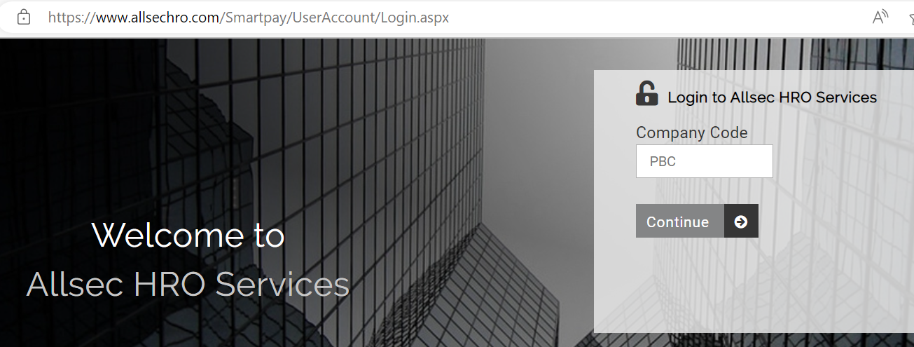

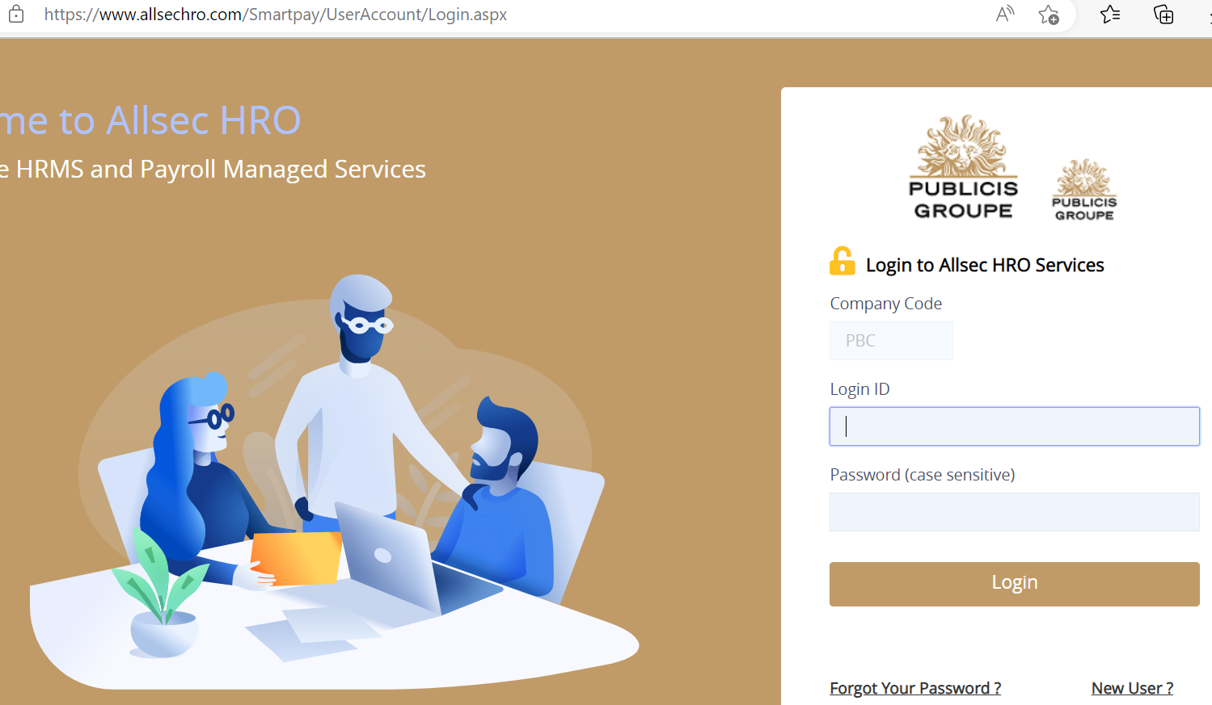

You shall be receiving Alumni credentials within 4 working days from your Date of Leaving.

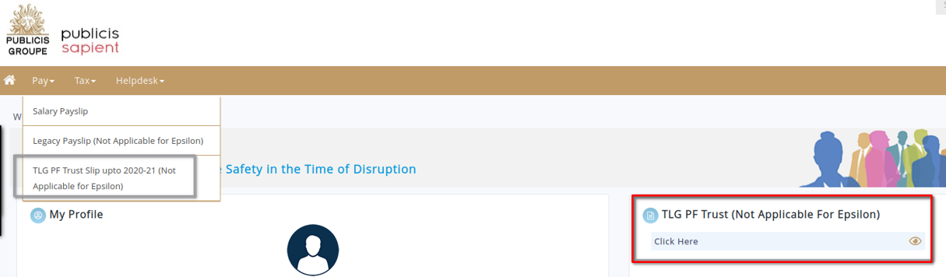

See your previous years’ PF statement here.

**Click this link** to view your latest PF statement, raise request for PF withdrawals / transfer and ask questions

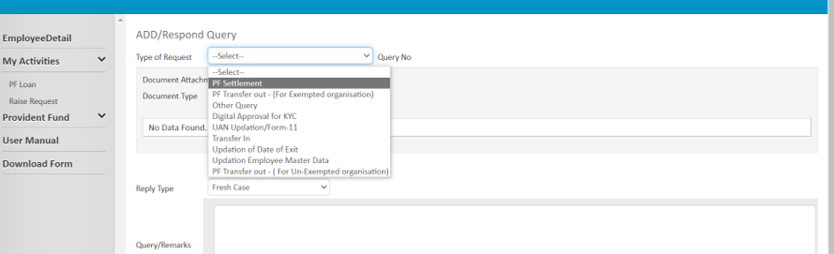

If you wish to transfer your PF, please upload Form 13 by getting it from your EPFO login.

**Steps to follow :**

1. Login to [UAN member Portal](https://unifiedportal-mem.epfindia.gov.in/) (<https://unifiedportal-mem.epfindia.gov.in/)>
2. Enter UAN number & Password
3. Click on Online Service > One Member – One EPF account
4. Fill the PF/EPS Account no.
5. Enter you Member ID/UAN & click on ’Get Details’
6. Select the last employer for which PF needs to be transferred
7. Click on Send OTP
8. Fill the OTP and submit the request

# Where can I find my previous years PF statements?

# Every year, PF statements are distributed to all employees, and they are instructed to download it from our payroll servicer provider portal. In case you have not downloaded your recent statements, you will be able to download it now for the last 3 years from [Allsec Technologies (allsechro.com)](https://www.allsechro.com/Publicisgroupe/Common/HomePage.aspx). Please ensure you download and save these documents before exiting the company.

# If I am submitting PF withdrawal forms after2 months of my exit, how much time will it take to process my PF settlement?

Your PF settlement will be processed and credited within 15 working days. In case of any question, please log a helpdesk request at the Allsec Alumni portal by raising a query.

In case you have not received your PF within the stipulated time, write to [PFHelpdeskExited@publicissapient.com](mailto:PFHelpdeskExited@publicissapient.com)

# Where can I find out about my Provident Fund account number and UAN number required for the forms?

Your Provident Fund account number and UAN number are printed on the right-hand side of your Payslip as shown below –

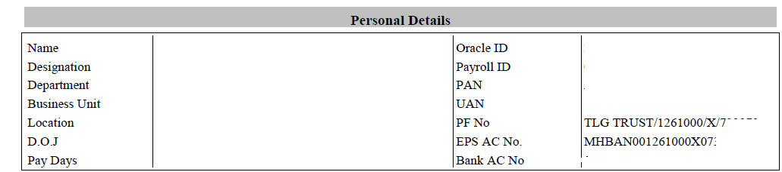

# Where is the PF account of Publicis Sapient kept?

The Provident Fund accounts of Publicis Sapient are maintained by a separate trust called “TLG INDIA PRIVATE LIMITED EMPLOYEES PROVIDENT FUND TRUST”. Address: 15th Floor, Urmi Estate, Tower A, 95 Ganpat Rao Kadam Marg, Lower Parel (W), Mumbai – 400013. Employee Pension Scheme (EPS) is deposited at EPFO Mumbai Bandra.

# What is EPS?

EPS is Employee’s Pension Scheme for which contribution is made by the employer. If you are eligible for EPS membership, you will be able to see EPS account number in your pay slip. If your tenure is more than 6 months in the organization, then you will be eligible to withdraw the pension fund (EPS). If you want to withdraw the EPS amount, you need to submit a request through UAN at [EPFO portal](https://unifiedportal-mem.epfindia.gov.in/memberinterface/).

# How can I change my bank account number at EPFO ?

* Step 1: Visit [Unified Member Portal](https://unifiedportal-mem.epfindia.gov.in/memberinterface/) & Login with Username and password.
* Step 2: Click the ‘Manage’ tab
* Step 3: Select ‘KYC’ from the drop-down menu
* Step 4: Select bank and fill ‘Bank Account Number, Name, and IFSC code’. Click ‘Save’
* Step 5: After this is approved by the employer, updated bank details will be visible in the approved KYC section

# Gratuity

1. **Am I entitled to Gratuity? If so, how will I receive it? Will Gratuity pay as a taxable or non-taxable component?**

If you have continuously worked at Publicis Sapient for 4 years, and 190 days (1650 days), including your assignment duration), you are entitled to Gratuity. The Gratuity amount will be processed within 30 days from your exit date, and it will be credited to your India salary account through TLG India Pvt. Ltd. Gratuity trust as non-taxable component. Hence, the gratuity amount will not be shown under Full & Final settlement and Form 16.

1. **What is the calculation of Gratuity?**

Gratuity is calculated on the rate of last drawn basic salary.

Calculation:

(Last drawn monthly Basic Salary x 15 x no. of years of service) / 26

*Note: - Basic salary is 35% of Base Salary.*

# Corporate card

1. **How will the dues against my Amex Card be settled?**

Any personal transactions/outstanding on your Amex card needs to be settled by the individual (you). Please note, if there is an outstanding amount on your Amex on account of personal transactions, your Full & Final settlement will not be released. Your F&F will be released only when your Amex account balance reflects as **NIL,** as well as all other clearances done. If the outstanding amount is an official expense, it needs to be claimed against original receipts / per diems. The respective team will reach out to you for the next steps.

# Medical Insurance

1. **Since I paid for my parent’s medical insurance policy, will it remain to be effective?**

The policy will continue to be) applicable till your exit date.

1. **Will I be entitled to self & immediate family medical insurance that was provided while I was working at Publicis Sapient?**

You are entitled to all the insurance claims (medical & personal) applicable till your exit date.

1. **How will my medical insurance be handled after I exit? I have unclaimed expenses?**

Please submit your bills as per the process to the Med claim POC. Medi Assist Customer Contact Centre (available 24X7, 365 days) 18004191151 [publicis@mediassistindia.com](mailto:publicis@mediassistindia.com)

1. **How can I download ecard for self and for my family?**

It is strongly recommended that you download the MediBuddy app and validate your details.

Log in to [**MediBuddy**](https://portal.medibuddy.in/Home.aspx) with your credentials in the format mentioned below:

o **User Name:** XXXXXX@sapient where XXXXXX refers to your full Career Settings (CS) ID

**Password**: Your DOB in "DDMMYYYY" e.g., 01121999 if your DOB is 1st December 1999

* Click on the **enrolment** tab situated on top of the screen
* Update beneficiary details and revalidate before submitting
* Click on ‘Confirm’ and then on ‘OK’ to submit your selection
* Once these details are submitted, click on the ‘**Home’** tab
* Click on the **Policy** tab to view or download your E-cards

1. **When I call TPA’s Call Center/Office, how will they identify me?**

To identify yourself, please mention your Policy Number or your Health Card Number to the Call Center Executive.

The executive may verify other details like your Address, Insurer, Date of Birth, Employer Details, etc. On establishing your identity, they will answer your queries.

1. **What is the time limit for filing a claim?**

Intimation to the TPA/Insurance Company should be given within 7 days of hospitalization. Hospitalization claim should be filed within 15 days of discharge from the hospital. Post-hospitalization, claim should be filed within 5 days of the last bill.

1. **Can I go to the network hospital, show my E-card and get the Cashless facility?**

No. The TPA’s card does not function like credit/debit card. You can avail of cashless facility at a network hospital subject to pre-authorization by the TPA. This form is to be sent by the TPA to the hospital where you plan to seek the treatment.

1. **In case of any difficulties with the TPA, who can I contact?**

Please reach out to the Medi Assist Customer Contact Centre (available 24*7, 365 days) 18004191151

**publicis@mediassist.in**

# Car lease and other benefits

1. **How will my Car lease get closed?**

People who have enrolled for car lease scheme at Publicis Sapient have to initiate foreclosure process. Any pending amount due on the car lease scheme has to be paid by the individual within 30 days of the car lease termination or foreclosure request.

1. **Am I still eligible to seek counseling under Publicis Sapient Benefits?**

This benefit is valid only until your last working date.

1. **How will the transport enrollment / parking slot be settled?**

You will be charged for transport enrollment/ parking slot only until your Last Working Day. Transport/parking charge deductions happens with a lag of one month.

# 4. How do I activate my Sodexo Meal Card (now Pluxee)?

The Pluxee Meal card must be activated before usage which can be done by following some simple instructions mentioned in the welcome e-mail or welcome kit that you will receive along with the card.

Activate your card online by visiting the card activation portal [https://activation.consumers.pluxee.in](https://activation.consumers.pluxee.in/)

* Enter your official registered Email Address/Mobile number
* Enter the 12 digit-card reference number (mentioned on the Welcome email / Letter)
* Click on ‘Get Activation Code’
* Provide officially valid document details to complete KYC
* Enter activation code (received on Email/SMS)
* Complete OTP-based mobile number verification
* Click on ‘Activate Card’

*Officially Valid Documents include Passport, Driving License, Voter ID, Offline Aadhaar

**IMPORTANT LINKS AND CONTACT INFORMATION (For Sodexo)**

* + **Customer Support – 022 69196919/ 022 49196919**
  + **Write to Sodexo:** [consumer@india.sodexo.com](mailto:cardsupport.in@sodexo.com)
  + **Card Activation Portal –** [https://activation.consumers.pluxee.in](https://activation.consumers.pluxee.in/)
  + **KYC portal:** [https://kyc.consumers.pluxee.in](https://kyc.consumers.pluxee.in/)
  + **Sodexo-Zeta on Web–** [https://web.consumers.pluxee.in](https://web.consumers.pluxee.in/)

# Personal belongings at office

1. **What happens to my desk in office, I have personal stuff in my drawers/desk?**

Please make sure you reach out to Office Services POC’s as per your Publicis Sapient location prior to the date of visiting office along with your seat number.

Once you are at office, please request the security staff to handover your belongings from your drawer to you.

# Background Verification

1. **What will happen to my background verification queries from the prospective employer? Will you communicate to them that my employment was terminated?**

Please request your new employer to send an email to [employmentverification2@publicissapient.com for your background verification. ,](mailto:employmentverification2@publicissapient.com%20for%20your%20background%20verification.%20,%20) The concerned person at Publicis Sapient will reply with your employment details (name, duration &designation/title). Publicis Sapient has a neutral reference policy, which means that if your prospective employer contacts us for a reference, we will limit our response only to confirmation of your employment dates and designation/titles.

# Contact Email

For all other queries, please write to us at the following email IDs:

* Salary or Full & Final settlement: [Exitindia@publicissapient.com](mailto:Exitindia@publicissapient.com)
* PF Transfer/withdrawal: Allsec Alumni portal
* Employment Verification: [EmploymentVerification2@publicissapient.com](mailto:EmploymentVerification2@publicissapient.com)
* Any other concerns: [Exitindia@publicissapient.com](mailto:Exitindia@publicissapient.com)